CASA OF ARIZONA
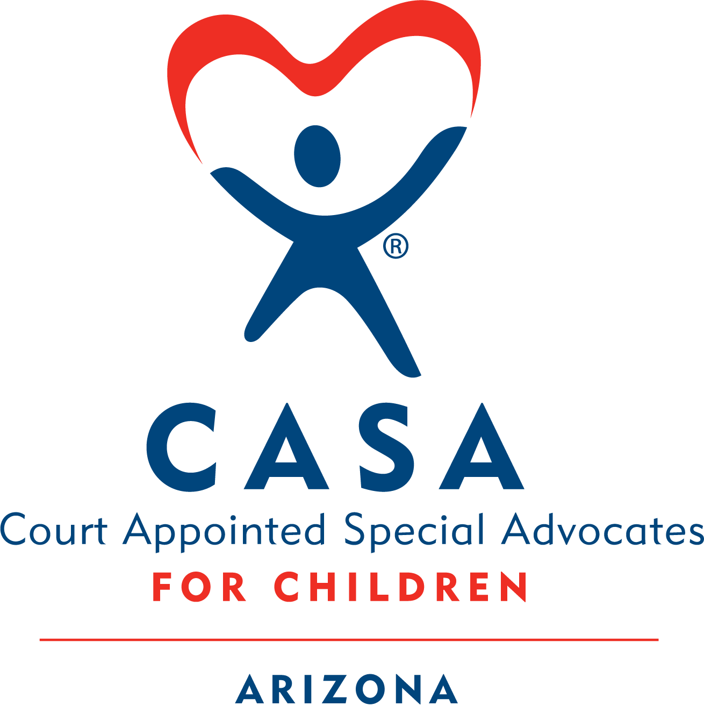

Module 3 Homework
Contents
❖ Activity 3.1 Understanding Mental Illness 2
❖ Activity 3.2 Childhood Trauma 5
❖ Activity 3.3 Adverse Childhood Experiences (ACEs) & Positive Childhood Experiences (PCEs) 8
❖ Activity 3.4 Trauma Informed Principles 10
❖ Activity 3.5 Resilience 10
❖ Activity 3.6 Obtaining Confidential Records 11
❖ Activity 3.7 Rosa Case 13

Activity 3.1 Understanding Mental Illness
Read the following information about mental illness.
DEFINITION
According to the National Alliance on Mental Illness (NAMI), “A mental illness is a condition that impacts a person’s thinking, feelings, behavior or mood. These conditions deeply impact day-to-day living and may also affect the ability to relate to others.” (NAMI, https://nami.org/About-Mental-Illness/Mental-Health-Conditions)
Definitions of mental illness have changed over time, across cultures and across national—and even state—boundaries. Mental illness is diagnosed based on the nature and severity of an individual’s symptoms according to definitions published in the The Diagnostic and Statistical Manual of Mental Disorders (DSM -5), currently in its fifth edition, Serving as the American Psychiatric Association’s (APA) classification and diagnostic tool, in the United States, the DSM serves as a universal authority for psychiatric diagnosis. r. The term “dual diagnosis” indicates that an individual has both a psychiatric disorder and a substance abuse problem.
CAUSES
A mental health condition usually has its origins in multiple, overlapping causes, which may include genetics, biology, environment, and life stressors. Mental illness is not caused by personal weakness or a character defect.
No single model or perspective accounts for all instances of mental illness. Some disorders have a predominately biological or neurological basis; others seem to be related to life experiences, trauma, or difficulties in communication.
The most helpful stance for you to take in your CASA/GAL volunteer work is to accept that mental illness can affect a person—mentally, physically, psychologically, socially, emotionally, and spiritually.
IMPACT OF PARENTAL MENTAL ILLNESS ON CHILDREN
A parent’s mental illness can significantly affect a child, potentially leading to social, emotional, or behavioral problems. According to Healthy Place, children of a parent with mental illness may experience the following impacts:
- Inappropriate levels of responsibility (also known as “parentification”)
- Self-blame for their parents’ problems
- Anger, anxiety, or guilt
- Embarrassment, shame, or isolation
- Increased risk of school-related problems, drug use and poor social relationships
- Risk of mood disorders, alcoholism, and personality disorders
However, parental mental illness doesn’t automatically sentence children to a life of problems. Whether a child can thrive despite these challenges depends on the strengths and protective factors present in the family, as well as the child’s level of resilience. As a CASA volunteer, you can recommend services that build on a family’s strengths and help them overcome the challenges they face.
UNTREATED MENTAL ILLNESS
The biggest obstacle facing those suffering from mental illness is the lack of appropriate, effective treatment. This lack may result from misunderstanding the need for treatment or being afraid to seek it due to the stigma associated with mental illness in American culture. It may also result from a lack of access to treatment. There may not be treatment available in a person’s community, or the person may not be able to pay for it.
Untreated mental illness can lead to isolation and despair for individuals and families. Some parents may be so incapacitated by anxiety or depression that they are unable to care for their children. Or, some may hallucinate or have delusions, which make them a danger to themselves or their children. It is critical for you as a CASA volunteer to focus less on a parent’s diagnosis and more on his/her ability to provide a safe home for the child. The degree to which a parent’s functioning is impaired will vary from mild to severe. It is important to note that with medication and/or therapy most people can function normally.
MENTAL ILLNESS AND CHILD WELFARE
To understand the impact of mental illness in a family, it is critical to examine if a parent’s level of functioning is sufficient to keep a child safe, and whether another competent adult is present in the home. A person’s level of functioning is the result of many factors; not all are related to mental illness. It is important to distinguish between mental illness and other kinds of limitations. For example, many adults have limited intellectual abilities or specific learning disabilities. These limitations range in severity. By looking beyond the diagnosis, to level of functionality, you can make recommendations to remedy the problems that caused family involvement in the child protective services system.

ASSESSMENT
It is not your task to diagnose mental illness. However, it is important to be aware of warning signs or indicators that may affect the health or safety of the child so that you can alert the DCS caseworker about your concerns.
The following are some indicators that may point to the need for professional assessment:
- Social withdrawal: “Sitting and doing nothing”; friendlessness (including abnormal self-centeredness or preoccupation with self); dropping out of activities; decline in academic, vocational, or athletic performance
- Depression: Loss of interest in once pleasurable activities, expressions of hopelessness or apathy; excessive fatigue and sleepiness or inability to sleep; changes in appetite and motivation; pessimism; thinking or talking about suicide; a growing inability to cope with problems and daily activities
- Changes in Communication & Thinking: Confused thinking; strange or grandiose ideas; an inability to concentrate or cope with minor problems; irrational statements; peculiar use of words; excessive fears or suspicions
- Expression of feeling disproportionate to circumstances: Indifference even in important situations; inability to cry or excessive crying; inability to express joy; inappropriate laughter; anger and hostility out of proportion to the precipitating event
- Behavior changes: Hyperactivity, inactivity or alternating between the two; deterioration in personal hygiene; noticeable and rapid weight loss; changes in personality; drug or alcohol abuse; forgetfulness and loss of valuable possessions; bizarre behavior (such as skipping, staring or strange posturing); increased absenteeism from work or school.

TREATMENT
Availability of mental health treatment varies, and its effectiveness depends on a variety of factors. Treatment options can include medication, counseling or therapy, social support, and education. A well-designed treatment plan takes individual differences into account.

CULTURAL CONSIDERATIONS
Different cultural communities perceive mental health conditions differently. Cultural background can affect whether people seek help, what kind of help they turn to, their ways of coping, the kinds of treatment that work and the barriers to receiving effective care. It’s crucial that professionals take culture into account when evaluating mental illness and providing treatment options.
WHAT A CASA VOLUNTEER CAN DO
- When you’re concerned that a mental illness has gone undiagnosed, you can recommend a mental health assessment of a parent or child.
- You may request consultations with a parent’s or child’s mental health care provider or review documents from the provider.
- When you encounter resistance to a label, diagnosis, or treatment, you can become aware of ethnic or cultural considerations. The standards for research and definitions of health, illness and treatment have historically derived from a white, middle-class perspective.
- When appropriate, you can ensure that children are provided age- appropriate explanations of their own or their parent’s mental illness diagnosis by a qualified individual.
- When appropriate, you can advocate for holistic treatment that considers all aspects of an individual, including mental, spiritual, emotional, and physical, as opposed to one dimensional treatment.

It is helpful to remember that children of parents with abuse/addiction problems still love their parents, even though the parents may have abused or neglected them.
A Multimodal Approach
Managing mental health issues and the symptoms experienced by children and adolescents involves many modalities which may include: Medication treatment, Behavior therapy, Cognitive behavioral therapy (CBT), Dialectical behavioral therapy (DBT), Trauma focused cognitive behavioral therapy, Eye movement desensitization and reprocessing (EMDR), Play therapy, Child-parent psychotherapy.

Activity 3.2 Childhood Trauma
Part 1: Read about Child Trauma

Child Trauma
According to the National Child Traumatic Stress Network, child trauma occurs when a child witnesses or experiences an event that poses a real or perceived threat to the life or well-being of the child or someone close to the child.

Examples of child trauma could include:
- Witnessing domestic violence
- Being physically or sexually abused
- The death or loss of a loved one
- Being in an automobile accident
- Being present for a life-threatening natural disaster
The traumatic event often causes feelings of fear, helplessness or horror in the child, which may be expressed in a variety of ways. Overall, the child isn’t able to cope with the intense feelings and becomes overwhelmed by the event.
Types of Trauma
Trauma may be described in one of four ways. Each describes how often or to what level the person experiencing the trauma is affected.
Acute Trauma: A single incident that is limited in time (e.g., a car accident). The effects may include physical and emotional stress leading to feelings of being overwhelmed.
Chronic Trauma: Repeated traumatic events (e.g., witnessing recurring domestic violence between parents over several years). Because of the recurring and longstanding nature of chronic trauma, the effects can be cumulative and build up over time. Children at this level are often more vulnerable to everyday stress and have diminished ability to cope.
Complex Trauma: Includes both the exposure to chronic trauma and the lasting impact the trauma has on the child’s well-being. Complex trauma usually begins when a child is very young (under the age of 5) and often is a part of a child’s relationship with a caregiver (e.g., physical abuse by a parent).
Historical Trauma: A personal or historical event that causes emotional and psychological injury and can be transmitted from one generation to the next (e.g., slavery, forced placement in boarding schools). By the time children are involved in the child protection system, they have often experienced chronic and complex trauma, often at the hands of the people entrusted with their care.
Understanding How Trauma Affects Children
Children are affected by traumatic events they’ve witnessed or experienced in numerous ways. Two children may have very different reactions to the same traumatic event. The way a child is affected may depend on any or all of the following:
- The child’s age or developmental stage
- The child’s perception of the danger faced
- Whether the child was a victim or a witness
- The child’s relationship to the victim or perpetrator
- The child’s past experience with trauma
- The adversities the child faces following the trauma
- The presence/availability of adults who can offer help and protection
For many children, exposure to traumatic events may have long-term consequences that can affect behavior, school performance, and participation in high-risk behavior, health problems and relationship difficulties.
For young children unable to communicate emotions associated with experiencing trauma, the effects may be manifested as physical tension or health complaints.
Cultural Considerations
It is important to understand the cultural background of a child when assessing a child’s trauma history. Culture can influence how the trauma is experienced by the child. The way a child or family interprets the meaning of the trauma will influence how they respond to the traumatic stress.
Optional Reading:
Read the document What is Complex Trauma - A Resource Guide for Youth and Those Who Care About Them below.

What a CASA Volunteer Can Do

Exposure to trauma can have lasting impacts on children, affecting their behavior, worldview and sense of safety.

In your role as a CASA volunteer, working with children who have experienced trauma:
- Treat them as individuals - rather than seeing them as victims of the traumatic event.
- Consider their past experiences - While your work may initially focus on the event that brought a child into the child welfare system, the children you will work with may have long histories of trauma.
- Recommend that the child have a trauma screening - Consider that what others are seeing as misbehavior or lack of age-appropriate development may be trauma related. Trauma screenings or assessments are most often completed by therapists or clinicians to screen for a child’s history of exposure to traumatic events and can help all involved understand the child’s behaviors in the context of their life’s experiences.
- You should have frequent communication with therapists and others involved in the treatment of the child to gain better understanding. However, in your volunteer role, you should not try to provide therapy.
- Recommend that parents have trauma screenings - Parents within the system will often have their own unresolved trauma histories, which may have contributed to their circumstances. It may be appropriate for the parent to undergo a trauma screening as well. Viewing the parent’s behaviors and/ or the child’s reactions in the context of their trauma histories is integral to having compassion and understanding.

Activity 3.3 Adverse Childhood Experiences (ACEs) & Positive Childhood Experiences (PCEs)

Part 1: Click on the link below and watch a video on the Adverse Childhood Experiences Study:
ACES Video
Part 2: Click on the link below and review the information on Positive Childhood Experiences:
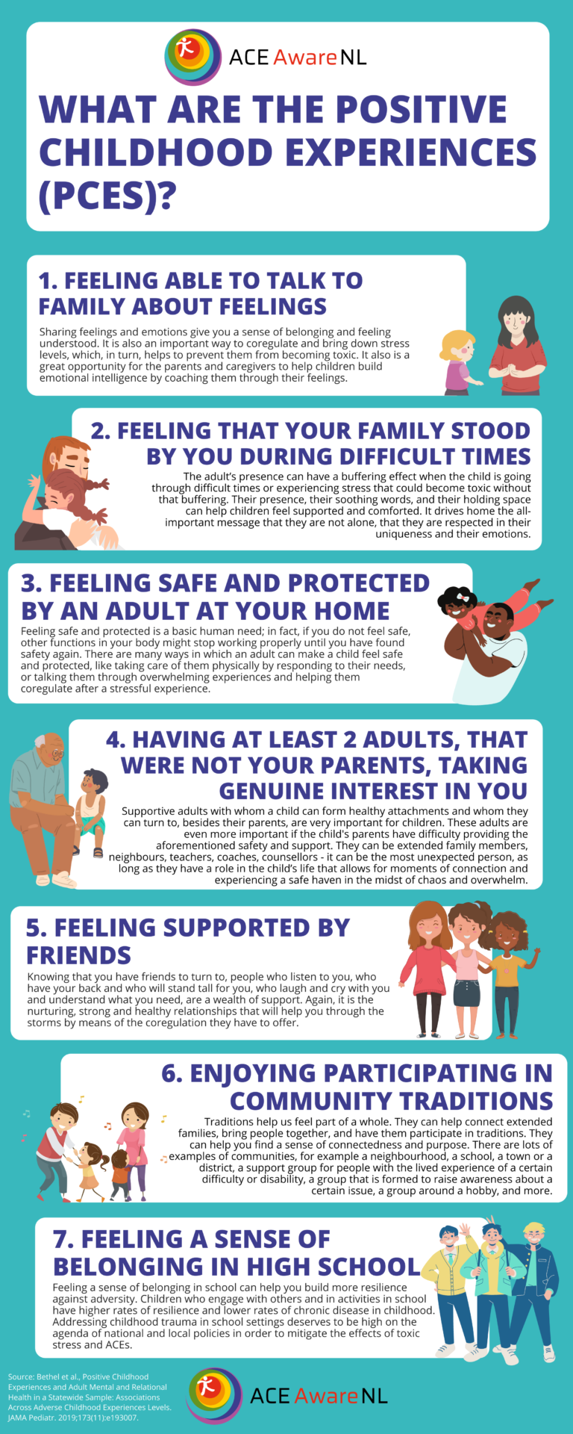

Activity 3.4 Trauma Informed Principles
Click on the link to read the Trauma Informed Principles Guide:

Activity 3.5 Resilience

Part 1: Click the link to watch the video on resilience:

How Resilience is Built

Part 2: Read more about resilience:

Resilience
According to the American Psychological Association (2022):
Resilience is the process and outcome of successfully adapting to difficult or challenging life experiences, especially through mental, emotional, and behavioral flexibility and adjustment to external and internal demands.
A number of factors contribute to how well people adapt to adversities, including the ways in which individuals view and engage with the world, the availability and quality of social resources, and specific coping strategies.
Psychological research demonstrates that the resources and skills associated with resilience can be cultivated and practiced (paras 1-3).
Resilience is influenced by protective factors and risk factors. One way to enhance resilience is to decrease risk factors and to reinforce/increase protective factors. Resilience requires a “combination of protective factors that enable people to adapt in the face of serious hardship and is essential to ensuring that children who experience adversity can still become healthy, productive citizens (Center on the Developing Child Harvard University, 2015, para 1)”.
The Seven C’s of Resilience
Studies of resilient people have repeatedly identified the presence of certain
protective factors: personal qualities, family, relationships, outlooks and skills
that assist them in overcoming hardships and finding success. Helping children
and youth, in the child welfare system, discover and/or develop some of these characteristics can significantly improve their chances for positive life outcomes
When we encounter stress in our lives, we tend to develop ways to overcome that stress or prevent it in the future. Over time, overcoming stress can be refined, practiced and improved, making us more resilient to adverse situations. Healthy ways of dealing with stress include fostering one of the “seven Cs”:

- Competence: Having knowledge, judgement, skills, and strengths that enable one to handle a situation effectively.
- Confidence: The belief in one’s personal abilities enough to take the risks necessary to learn and grow.
- Connection: Having strong ties to family and community, creating a sense of belonging
- Character: Having a solid set of morals and values to help determine right from wrong
- Contribution: Feeling like a valuable member of society able to make a difference
- Coping: Skills learned that allow the ability to handle stress appropriately.
- Control: The knowledge and ability to affect an outcome. The belief that you are not at the mercy of what happens to you.

Adapted from “The 7 Cs: The Essential Building Blocks of Resilience,” from Fostering Resilience, http://www.fosteringresilience.com/7cs.php.

Seven C’s Reflection
How can a CASA help foster and/ or reinforce the seven C’s of resilience with their appointed child(ren)?

How would you as the CASA on the Rosa Case strengthen and reinforce the 7 C’s? Note your thoughts on your homework worksheet and be prepared to share with your group in class.

Activity 3.6 Obtaining Confidential Records

Your Order of Appointment as a CASA volunteer will advise individuals that you are allowed access to records—even records that would otherwise be confidential—pertaining to the child in your assigned case.

- You should maintain multiple copies of your order of appointment to present when you visit an agency from which you seek information.
- The court order appointing you as the child’s advocate provides wide latitude to access that child’s records. Parents’ records are often more difficult to obtain. The best way to ensure your ability to obtain confidential records for a parent or other adult party to a case is to request those records from DCS.
- Information may be obtained through a legal process called “discovery,” where documents will be sent to your local CASA office. For some information, it may be up to the individual CASA volunteer to request those records.
- Plan to call ahead and request that records be pulled for you to read at a certain date and time. Some hospitals and agencies will allow you to make copies; others will send the copies to you. If you are denied access to records, contact your CASA coordinator.

As a CASA volunteer, you will have access to confidential information about children and the people involved in their lives. You will need to understand your responsibilities in dealing with the confidential information you have gathered.

The CASA volunteer may not release this information except to the:
- CASA program staff,
- the attorney(s) on the case,
- the caseworker,
- the court and others as instructed by law or local court rule.

There will be times when it will be tempting to share information with others, for example, when a person has just finished sharing information with you or when you believe doing so might help your assigned child. However, your role is to be an information gatherer for the court—not a transmitter of information to people with whom you are not authorized to share it. If certain information needs to be shared, consult with your program coordinator to determine how you might facilitate communication among others without violating confidentiality yourself. Mistakes in handling confidential information can be detrimental to the children involved. When in doubt, discuss any confidentiality concerns with your CASA coordinator.

What Information Should the CASA Volunteer Share with the Child?
The CASA volunteer is expected to develop a meaningful relationship with the child in order to make sound, thorough and objective recommendations in the child’s best interest. The volunteer also ensures that the child is appropriately informed about relevant case issues, considering both the child’s age and developmental level, although it may be more appropriate for others on the team to share this information with the child. The child is informed in an age-appropriate manner of impending court hearings, the issues to be presented, the recommendations of the volunteer and the resolution of those issues. If there is any questions about what information should be shared with the child, ask your coordinator.

Should You Tell a Source That You Intend to Share Their Information?
When introducing yourself as a CASA volunteer, mention that your role includes gathering information in order to make recommendations to the court. Never promise that you will not share information received.

Sharing Information with Foster Parents
As a CASA volunteer, you are not the foster parents’ source of information about the child’s case. That is the responsibility of their licensing agency. Your job is to focus on the child’s needs. Foster parents may seek information from you about the children in their care, but foster parents’ contractual relationship is with DCS and their private licensing agency. To provide adequate care, foster parents do need to know relevant information regarding the child. In fact, federal law requires that DCS provide the foster parent with the child’s health and education records at the time of placement. The records should be updated periodically and each time the child is moved to another placement.

There may be instances, however, where you have information that would help a foster parent care for a child. Suppose, for instance, that you know the child has a history of sexual victimization and that he/she has been moved from an earlier foster home after an incident of acting out. The current foster parent does not have this information and there is another young child in the home. In such a case, it is clearly in the best interest of both the child and other children in the home that this information be shared. After discussing the issue with your CASA coordinator to determine the best approach, you should contact the DCS case manager and state a clear expectation that this critical background information be shared with the current foster care provider. As a CASA volunteer, you should not share this information yourself.

Activity 3.7 Rosa Case

So far, you have read the Dependency Petition, DCS first report to the court and contact logs written by the CASA. Now you will read a DCS Addendum Report to the court which is updating the court in advance of the first Review Hearing (please reference the Hearing Types definition in your volunteer manual from Module 2), the Minute Entry from the review hearing, another DCS Addendum Report updating the court on a specific situation related to Israel and contact logs summarizing information gathered by the CASA.
Here is the basic timeline, so far, the children were removed in early Jan 2024, the initial hearings were held in Jan 2024, the first Review Hearing was held in June 2024 and the court was updated on significant changes with Israel in July 2024.
Click the pdf below to read the latest documents for the Rosa case. As you read, it will be helpful to you to take notes of the pertinent information. You will be asked in future classes to work in groups to discuss what information you would include in the assessment section, opinions & concerns section and what recommendations you may make for this case. So, please keep these activities in mind as you read this information and take notes.

Citations

American Psychiatric Association. (2022). Trauma and stressor related disorders. In the Diagnostic and statistical manual of mental health disorder (5th ed., text rev.).

Beltre, B., & Mendenz, M. D. (2023). Child development. National Center for Biotechnology Information. Child Development - StatPearls - NCBI Bookshelf (nih.gov)

Center on the Developing Child at Harvard University (2016). 8 things to remember about child development. www.developingchild.harvard.edu.

Center on the Developing Child at Harvard University. (n.d.). Serve and return. Serve and Return (harvard.edu)

Child Welfare Information Gateway. (2023). Child maltreatment and brain development: A primer for child welfare professionals. U.S. Department of Health and Human Services, Administration for Children and Families, Children's Bureau. Child Maltreatment and Brain Development: A Primer for Child Welfare Professionals (cwig-prod-prod-drupal-s3fs-us-east-1.s3.amazonaws.com)

First Things First. (n.d.). The first five years. The First Five Years (firstthingsfirst.org)
Green, N. (2022, May 9). Healing from childhood trauma: The roles of neuroplasticity and EMDR. PsychCentral. Neuroplasticity and Childhood Trauma: Effects, Healing, and EMDR (psychcentral.com)

Hornor, G. (2019). Attachment Disorders. Journal of Pediatric Health Care, 33, 612-622.Attachment Disorders - Journal of Pediatric Health Care (jpedhc.org)

Monaco, E., Schoeps, K., & Castilla-Montoya, I. (2019). Attachment styles and well-being in adolescents: How does emotional development affect this relationship? National Center for Biotechnology Information. Attachment Styles and Well-Being in Adolescents: How Does Emotional Development Affect This Relationship? - PMC (nih.gov)

Ogunye, M. (2023, November 27). Reflections on the attachment relationship between an infant and caregiver. The Attachment Relationship in Infancy (zerotothree.org)

Purvis, K.G. (Producer). (2018). TBRI Animate: Attachment [Video]. Karyn Purvis Institute of Child Development. Karyn Purvis Institute of Child Development (tcu.edu)
Smith, M., Robinson, L., Segal, J. & Reid, S. (Updated November 3, 2023). Attachment issues in children. HelpGuide. Attachment Issues and Attachment Disorders in Children (helpguide.org)

